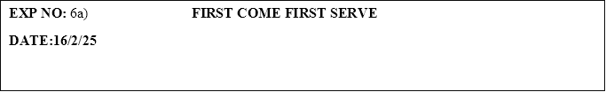

**PROGRAM:**

#include <stdio.h>

int main() {

    int n;

    int burstTime[10], waitingTime[10], turnAroundTime[10];

    int totalWaitingTime = 0, totalTurnAroundTime = 0;

    printf("Enter the number of processes: ");

    scanf("%d", &n);

    printf("Enter the burst time of the processes:\n");

    for (int i = 0; i < n; i++) {

        scanf("%d", &burstTime[i]);

    }

    waitingTime[0] = 0;

    for (int i = 1; i < n; i++) {

        waitingTime[i] = burstTime[i - 1] + waitingTime[i - 1];

    }

    for (int i = 0; i < n; i++) {

        turnAroundTime[i] = burstTime[i] + waitingTime[i];

    }

    printf("\nProcess Burst Time Waiting Time Turn Around Time\n");

    for (int i = 0; i < n; i++) {

        printf("%d\t\t%d\t\t%d\t\t%d\n", i, burstTime[i], waitingTime[i], turnAroundTime[i]);

    }

    for (int i = 0; i < n; i++) {

        totalWaitingTime += waitingTime[i];

        totalTurnAroundTime += turnAroundTime[i];

    }

    float averageWaitingTime = (float)totalWaitingTime / n;

    float averageTurnAroundTime = (float)totalTurnAroundTime / n;

    printf("\nAverage waiting time is: %.2f\n", averageWaitingTime);

    printf("Average Turnaround Time is: %.2f\n", averageTurnAroundTime);

    return 0;

}

**OUTPUT:**

Enter the number of processes: 2

Enter the burst time of the processes:

5

8

Process Burst Time Waiting Time Turn Around Time

0 5 0 5

1 8 5 13

Average waiting time is: 2.50

Average Turnaround Time is: 9.00